Beds available at our care homes in Oxfordshire | No Images? Click here

WHO WE ARE OUR APPROACH TO CARE RESIDENTS' STORIES FIND A HOME

We have beds available in Oxfordshire for elderly and frail people
Our homes in your area have considerable expertise and experience of working in partnership with healthcare professionals like you. ​We currently have bed availability at the following homes in your area:
Huntercombe Hall in Henley upon Thames >
Oaken Holt in Oxford >
Tall Trees in Chipping Norton >
Wytham House in Oxford >
Huntercombe Hall |  Henley upon Thames  42 beds offering nursing, residential and dementia care.  Email: Stephanie Jones  Call: 0808 223 5408 | 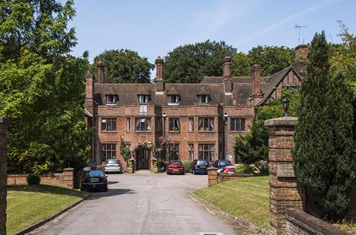

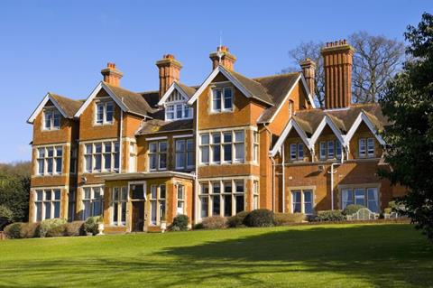 | Oaken Holt | Oxford  55 Beds offering residential and nursing care. Fresh new look including lounge, dining room and bedrooms.  Email: Bernie Boyle  Call: 0808 223 5408
Tall Trees |Chipping Norton  60 Beds offering nursing, residential and dementia care.  Email: Michelle Little  Call: 0808 223 5408 | 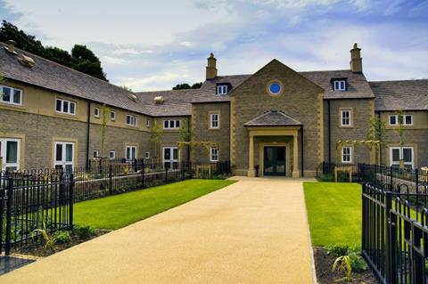

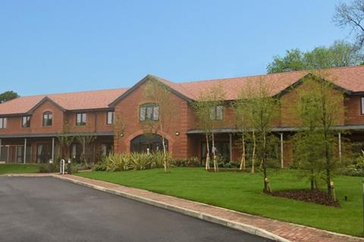 | Wytham House | Oxford  Newly-built home, within the Oaken Holt Estate for 40 elderly residents offering specialist dementia care.  Email: Koren Evans-Slade  Call: 0808 223 5408

Caring Homes Group, Bradbury House, 830 The Crescent, Colchester Business Park, Colchester, Essex, CO4 9YQ

