Experience the buzz when elite cycling returns to South Oxfordshire
People across South Oxfordshire will be able to experience the buzz of one of Britain’s biggest cycling events when The Women’s Tour returns to South Oxfordshire on Saturday 11 June.
Thousands of people are expected to line the route as about 100 professional riders race through the streets of Didcot, Wallingford and Crowmarsh. The race will also pass Benson, Shillingford, Dorchester, Berinsfield, Clifton Hampden and Culham.
Before entering South Oxfordshire, The Women’s Tour will start mid-morning in Chipping Norton and will then pass through Cherwell, West Oxfordshire and the Vale of White Horse. The race will finish mid-afternoon in the centre of Oxford.
To see the full route map visit southoxon.gov.uk/womenstour.
Following successful events in 2019 and 2021, this will be the final year that The Women’s Tour will visit Oxfordshire, following three-year partnership with race organiser SweetSpot. For 2022, the county will host 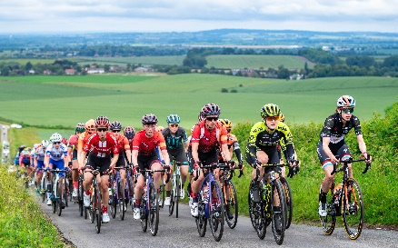
the sixth and final stage of the Tour in what promises to be a spectacular finale.
Communities across the district are being encouraged to mark the occasion – this could be as simple as lining the route to cheer the riders on, putting up bunting, flags, or cycling inspired artwork, creating cycling themed window displays or having cycling themed events.
Cllr Sam Casey-Rerhaye, Cycling Champion at South Oxfordshire District, said: “I’m really pleased that the Women’s Tour is returning to South Oxfordshire. The race provides us with a great chance to highlight our wonderful towns, villages and countryside to a wider audience. It also helps to inspire people, particularly women and girls, to take up the sport and get on their bikes to get and about.”
Cllr Maggie Filipova-Rivers, Cabinet Member for Community Wellbeing at South Oxfordshire District Council, said: “The Women’s Tour is such a great occasion. We want to see lots more people travelling by bike across Oxfordshire and events like this really help to increase people’s interest in cycling. I urge everyone on the route to get together in your communities to make the most of this event.”
More information about the event, including the race times, will released in the coming weeks. For further details, visit southoxon.gov.uk/womenstour.
About the Women’s Tour
Created by SweetSpot Group in 2014, the Women’s Tour is the UK’s first international stage race for women, bringing the world’s top riders to compete in Great Britain as a part of the UCI Women’s World Tour.
The race, which has been won by the likes of Marianne Vos (2014), Lizzie Deignan (2016, 2019) and Demi Vollering (2021), attracts an annual roadside audience of 300,000, as well as over three million fans through linear and online platforms.
Follow the Women’s Tour on Twitter (#WomensTour), Facebook, and Instagram or via the event’s official website at womenstour.co.uk.
You can find more information about the event on the official Women’s Tour website
Notes for editors:
photo attached of The Women's Tour riding through the Chilterns in South Oxfordshire - picture credit SWpix.

