Garsington Parish Council

The Monthly Meeting of the Parish Council was held in the Village Hall on Monday 9th May 2011 commencing at 7.30pm. The Chairman, Councillor Godfrey Eden presided; present were Cllrs Anne Eastwood, John Hieatt, Mike Patrick and Judith Westgate. Also present for part of the meeting were ten members of the public.

5/11/1. Apologies for Absence
None – all Councillors were present.

5/11/2 Acceptance of Office / Register of Interest
All Councillors signed their Declarations of Acceptance of Office in front of the Clerk who witnessed their signatures.
Each Councillor is to complete a new declaration of interests which will be returned to the Clerk and then filed with the Monitoring Officer at SODC.

5/11/3 Declarations of Interest on Agenda Items
None

5/11/4. Public Participation
Representatives of Garsington Sports & Social Club attended the meeting. They told the Council that the Club did not feel that the Parish Council should be seeking any increase in the ‘peppercorn’ rent that had been established in the original lease.
Although the Club paid only this token rental, it was said that the benefit to the Parish of the Club’s work to maintain the playing field, through the efforts of its volunteer labour and purchase of seed, fertiliser etc. could be valued at £19,000 or even more.
For the Parish Council the Chairman pointed out that the membership of the Club included a large number, perhaps even a majority, of people who are not residents of the village. The Council believed that it was wrong that the leisure activities of non-residents should be subsidised by the council tax payers of Garsington.
It was agreed that there should be a special meeting between the Council and the Club at which matters concerning future rental and maintenance charges could be discussed. The Clerk and Mr Tony Price, Chairman of the Club, will set the date.

5/11/5. Minutes of the Monthly Meeting held on 4th April 2011
After the correction of some typographical errors, the minutes as circulated were approved and signed as a true record.

5/11/6. Matters arising from the Minutes not covered elsewhere on the agenda
The Chairman said that there are no urgent safety issues requiring attention at the Play Area.

5/11/7 Finance
Pending the change of mandate required following the recent council election it was agreed that Chris Wright and Paul Bolam could sign any urgent cheques provided that the payment had first been agreed by the Council as a whole. The new signatories would be Cllrs Ann Eastwood and Judith Westgate.
Barclays Current Account at 28th April £28,841.98
Barclays Tracker Account at 10th March £50.97
Bank of Ireland at 6th April £40,046.90
Bank of Scotland (fixed deposit) £50,548.34
Bank of Scotland Deposit A/c £50,548.34 deposited for 12 months at 2.2% matures September 2011
The following cheques were approved for payment.
ColourPlus (April/May Newsletter) £831.21
Aon Limited (annual insurance premium) £1,831.56
Total Pest Control (UK) Ltd (moles in playing field) £168.00
SODC – dog bin emptying Jan – Mar £34.98
Southern Electric £15.46
ORCC (annual sub) £30.00
GBS Architects (Village Hall access audit) £389.40
OALC (annual sub) £318.64
Admin (April) £97.82
G Russell (Clerk’s salary) £369.69

The Council approved the increase in advertising rates for the Garsington Newsletter that had been proposed by Cyril Tomline. The new (old) rates are now: ¼ Page £12 per insertion (no change); ½ Page £24 per insertion (£18); and Full Page insertion £48 (£36). Discounts will continue for advertisers who book for 6 consecutive issues.

5/11/8 Planning
a. Applications (all Lawful Development Applications)
P11/W0464/LD 75 South End Garsington OX44 9DJ
Proposed outbuilding and new pool in walled enclosure.
The Parish Council is invited to comment if it is aware of the history of the land over the past ten years; the Council has no information about this and cannot comment.
P11/W0557/LD Oxford Equestrian Centre Lower Road Garsington OX44 9DP
Use of 'Flat 4, Flat 6, Flat 8, Flat 10, and Flat 12' as shown on Drawing no. 1657 for residential use for persons without any connection with the Equestrian Centre (without compliance of Condition 3 of Planning Permission P94/N0227)
The Parish Council is invited to comment if it is aware of the history of the land over the past ten years; the Council has no information about this and cannot comment.
P11/W0556/LD Oxford Equestrian Centre Lower Road Garsington OX44 9DP
Use of 'Managers flat' identified as' Flat 1' on drawing no. P1657 for residential use by persons without any connection to the Equestrian Centre (without compliance with Condition 3 of Planning Permission P93/N0442).
The Parish Council is invited to comment if it is aware of the history of the land over the past ten years; the Council has no information about this and cannot comment.
P11/W0419/LB The Old School House 3 The Green Garsington OX44 9DF
To remove the existing open flue gas boiler from the kitchen. Install new gas condensing system boiler
The Council has no strong views about this application and will leave the decision to the planning officers.
b. Other planning matters
In the absence of District Cllr Elizabeth Gillespie no-one was able to report about the status of the District Council’s action regarding land next to Greenwoods in Pettiwell. The Clerk will contact Cllr Gillespie to see if she has any information that can be passed on.

5/11/9. Correspondence to Chairman and Clerk
i. The Council noted a letter from the County Council concerning the closure of Denton Lane on 11 July. An alternative route will be signed while work is progressed.
ii Information about changes to the bus services with effect from 6th June has been received. Many residents will be adversely affected. The County Council will be asked for the reasons for these changes and why so little notice has been given. The Clerk will circulate Councillors with any further information that he obtains and County Cllr David Turner will be asked to intervene.
iii. Mrs M Woodward-Trinder, formerly of Garsington and now resident of Cowley has written to the Council seeking to reserve a double plot in the Burial Ground. This was approved and the Clerk will write to explain the fees.
iv. The Council has been invited to send a representative to the AGM of CPRE Oxfordshire to be held in Thame on Saturday 14 May. No-one is available to attend.

5/11/10 Village Maintenance
The Chairman said that he had made some slight modifications to Mr Tipping’s job description which involved some changes to hours allowed and indicated that a small increase in honorarium is required. He will discuss these matters, together with some issues concerning behaviour and dealings with village residents, before the Council’s June meeting.
Cllr John Hieatt reported that the new School Crossing Supervisor had told him that he would like there to be road signs warning drivers approaching from both directions that they were nearing the location of a school crossing. It was thought that these signs might have been included in the County’s original proposal; Cllr Anne Eastwood said that she would check with Mrs Wynn Jones.

5/11/11 Sports & Social Club Lease
The Chairman said that he thought that the discussion which had taken place earlier under Public Participation had been very useful. The proposed meeting should go ahead but the solicitors would not be invited to attend on this occasion.

5/11/12 Village Hall
It was understood that there are some outstanding fees payable. Some are due to the architects, Andrews Eades, and some to the District Council for the approvals under Building Regulations. Invoices that are paid by the Parish Council need to be submitted direct to the Council.

5/11/13 Registration of Playing Field and other Parish Council land.
Cllr Mike Patrick confirmed that he has sent off the application to register the Memorial Playing Field under the Queen Elizabeth II Fields Fund and he had been informed that this was the first application from Oxfordshire. There will now be a site visit before the application is approved.
Cllr Judith Westgate has volunteered to register the Council’s ownership of the Memorial Playing Field with the Land Registry and the Clerk will supply her with the papers that she needs to do this.
Cllr Patrick has the documents that are needed to apply for Parsler’s Piece also to be registered under the QE II scheme.

5/11/14 Parish Council Vacancies – Co-options
The Clerk said that the Council has been instructed by David Buckle, Returning Officer at the recent elections, that co-options to fill some or all of the four vacancies on the Council must take place by 24th June. The matter will therefore be placed upon the agenda for the June meeting.

Meeting closed at 8.56 p.m.
52 Wheatley Road
Garsington
Oxford
OX44 9ER
29th May 2011
Clerk to the Council
Mr Geoffery Russell
The Pigeons
High Street
Dorchester on Thames
Oxfordshire
OX10 7HH

Garsington Village Hall Refurbishment

Dear Geoff,
Thank you for a full and considered reply to my letter outlining possible ways forward with financial help from the parish council towards the village hall refurbishment. I will try to answer all of the points in your letter.
Firstly, those concerning money and payment details, then the principles covering your grant to the village hall and ‘terms of payment’.
You will appreciate that over the last eighteen months the village hall management committee has concentrated its efforts on securing grant funding from WREN, LEADER and SODC as well as liaising with architects and planners. The amount of work and effort required has been monumental. We have tried to keep everyone informed about progress and I trust the council found useful the updates that I provided in my letter of 15th March. The achievements and future land-mark dates in that letter still stand. The 22nd of June is when we will know if we have our final allocation of grant money from SODC .That key date will lead us into the next phase of the project. Precise detailed planning will then take place with regard to what the parish council is being asked to pay for and the expected cash flows. Put simply if we have not acquired all of the funding we need we will need to adapt our plans. Whatever the situation, we will work closely with you and the other fund providers to move the project forward within the time frame I outlined to you in my previous letter. I cannot be more precise about this at this stage.
With regard to VAT we were already aware of the details you outlined in paragraphs six, seven and eight of your letter. There are difficulties however in the details of grant awards. In our grant applications we, the management board, were asked to declare if we paid VAT. We do and our grant applications were submitted on this understanding. The village hall management committee is the named grant applicant NOT the parish council. This complicates the issue. The parish council is a third party contributor to the project and the rules of the grant funding bodies make it clear that VAT must be paid by applicants, when appropriate. I have spoken to all three bodies. WREN and SODC are relaxed and understanding about VAT payments. LEADER, however have let it be known that they would withdraw their funding offer if we tried to circumvent VAT payments. They may also consider reducing the amount they offer us in line with any VAT savings we may make. In my latest discussion with them they agreed that we should meet to discuss this once we know if we have SODC money. We are going to meet with them soon after the 22nd June. In the meantime we are seeking professional advice specifically about the position of ‘third party funding’. I wholeheartedly agree with you that bodies like WREN, LEADER and SODC are aware of the tax situation. We have to work with them and be aware of their own rules as well as those of custom and excise. The VAT position you helpfully outlined to us is that relating to the parish council. The grants issue is more complicated. I hope with good professional advice we can work out these difficulties.
I turn now to the ‘terms of payment’ issues outlined in your letter. The village hall management board understands your concerns about financial responsibility to the village. May I refer you and parish councillors to sections 24 and 25 of the Village Hall charitable deeds (copy attached) which state clearly how the buildings and land should be disposed of in the ‘interests of the inhabitants of Garsington’. I would suggest that this more than covers your concerns. To formalise matters I would be happy to present a formal resolution to the village hall management board thus:
The village hall management board formally recognise and thanks Garsington Parish Council for its grant of £90,000 towards the cost of refurbishment of the hall. The board instruct the trustees to acknowledge this in the future should the hall and land ever need to be disposed of in line with trustee’s duties under sections 24 and 25 of the charity deed. Dated…………2011
This would formalise the role of the parish council and serve as an additional public record.
Perhaps you will let me know what councillors think of this proposal.
Finally, on to the fund itself and the village hall business plan. We are delighted with your assurance in writing, to us, that the council has agreed to release the £90,000 fund and that this is publicly recorded in the minutes of the council reference 3/11/12. This safeguards the tens of thousands of pounds that we have already raised from other sources and the years of work that we have put into the project. I would be happy to share with you and councillors, our village hall business plan and other documentation connected with the improvement project. May I suggest in order to save time (and some paper) that I make a short presentation to the parish council before or after your next meeting or on another occasion. I would be happy to answer any questions that councillors may wish to raise.
Please let me know if the council would find this useful.
Once again, thank you for your continued help and advice.

Yours sincerely,

Adrian Townsend

Adrian Townsend
Garsington Village Hall Management Board
Attachments: sections 24 and 25 Garsington Village Hall charity commission deed
no. E 133,167
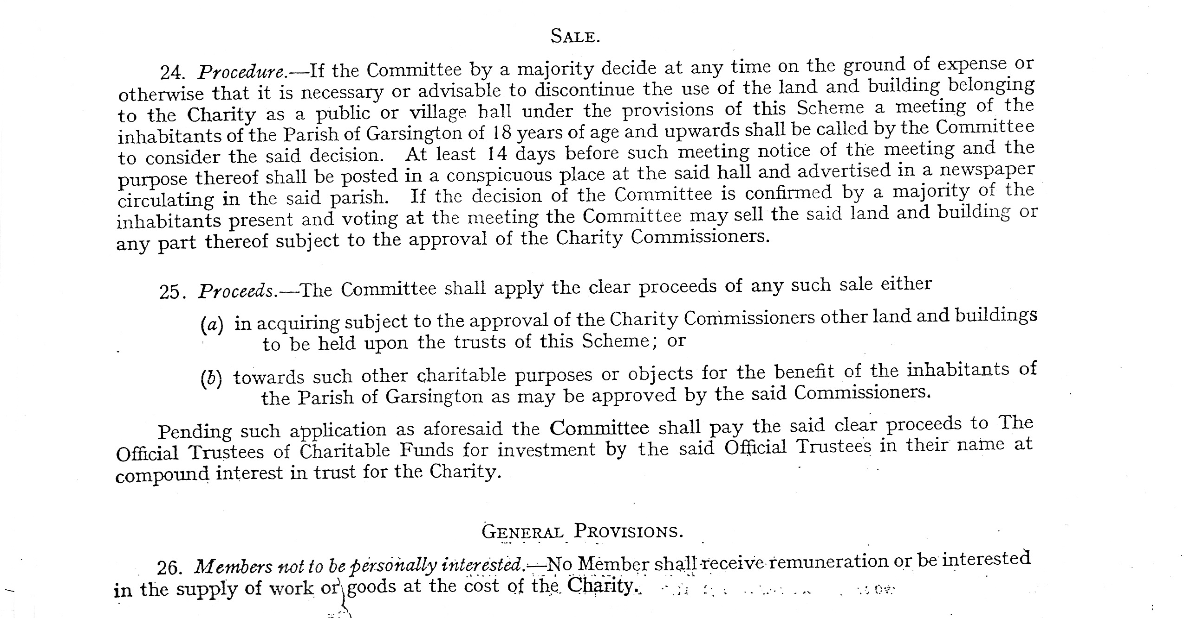

Attachment 1

